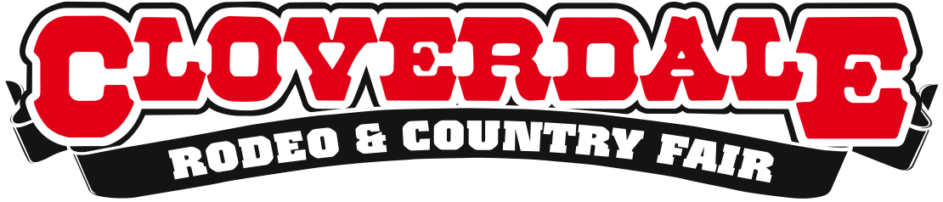
CLOVERDALE RODEO RESULTS: FRIDAY MAY 15, 2015

Surrey, BC – The first night of the 2015 Cloverdale Rodeo was met with fierce competition and a three-way tie for first place in bareback riding. Canadian bull rider Dakota Buttar (Kindersly, SK) took first place with an impressive 87.5 points. Full results below:

First Performance Results – Pool A – 7:30pm

Bareback Riding
1. Caleb Bennett, Tremonton, UT – 85.5 points
1. Clint Laye, Cadogan, AB – 85.5 points
1. JR Vezain, Cowley, WY – 85.5 points
2. Jared Smith, Eastland, TX – 85 points
2. Kyle Bowers, Calgary, AB – 85 points
Saddle Bronc Riding
1. Cort Scheer, Elsmere, Neb – 89 points
2. Ryan Geiger, Duchess, AB – 84 points
3. Wade Sundell, Boxholm, IA – 83 points
4. Luke Butterfield, Ponoka, AB – 82 points
4. Tyrell Larson, Inglis, MB – 82 points
Bull Riding
1. Dakota Buttar, Kindersly, SK – 87.5 points
2. Clayton Foltyn, Winnie, TX – 85.5 points
2. Steve Woolsey, Payson, UT – 85.5 points
3. Zach Oakes, Tonasket, WA – 84 points
4. Wade Sundell, Boxholm, IW – 82.5 points
5. Howdy Cloud, Kountz, TX – 80.5 points
Ladies Barrel Racing
1. Lisa Zachoda, Okotoks, AB – 16.45 seconds
2. Stephanie Mather, Medicine Hat, AB – 16.58 seconds
3. Julie Leggett, Kamloops, BC – 16.61 seconds
4. Deseraie Earl, Bismarck, ND – 16.65 seconds
The Cloverdale Rodeo continues with two competitions on Saturday, May 16th at 2:30pm and 7:30pm, Sunday May 17th at 2:30pm with final competitions happening on Monday May 18th at 2:30pm.

For more information, please visit www.cloverdalerodeo.com.

-30-

Colin Wong  Cloverdale Rodeo and Country Fair  Direct: 604-637-6649  Cell: 604-638-0412  cwong@lbmg.ca | Lesley Chang  Cloverdale Rodeo and Country Fair  Direct: 604-637-6661  Cell: 604-375-1461  lchang@lbmg.ca

