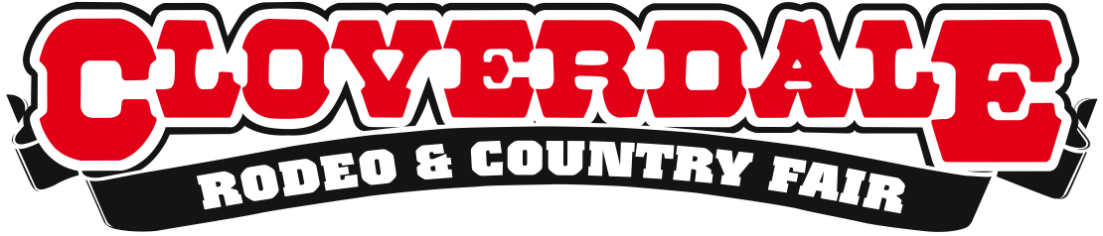
CLOVERDALE RODEO RESULTS: SATURDAY MAY 16, 2015

Surrey, BC – The second day of the 2015 Cloverdale Rodeo continued day one’s intense competition, with Canadian Tyler Pankewitz taking first place in the bull riding after earning a whooping 90 points. Full results below:

Second Performance Results (Pool A) – 2:30pm

Bareback Riding
1. JR Vezain, Cowley, WY – 86 points
2. Ty Taypotat, Regina, SK – 85 points
3. Jared Smith, Eastland, TX – 84 points
4. Clint Laye, Cadogan, AB – 83.5 points
5. Kyle Bowers, Calgary, AB – 82 points
Saddle Bronc Riding
1. Rylan Geiger, Duchess, AB – 86.5 points
2. Wade Sundell, Boxholm, IA – 85.5 points
3. Tyrell Larson, Inglis, MB – 85 points
4. Troy Crowser, Whitewood, SD – 81.5 points
5. Luke Butterfield, Ponoka, AB – 80.5 points
Bull Riding
1. Tyler Pankewitz, Ponoka, AB – 90 points
2. Steve Woolsey, Payson, UT – 87 points
3. Zach Oakes, Tonasket, WA – 85 points
4. Jordan Hansen, Okotoks, AB – 84.5 points
5. Dakota Buttar, Kindersly, SK – 84 points
5. Howdy Cloud, Kountz, TX – 84 points
Ladies Barrel Racing
1. Sydni Daines, Innisfail, AB – 16.41 seconds
2. Britta OKeefe, Mohall, ND – 16.43 seconds
3. Julie Leggett, Kamloops, BC – 16.54 seconds
4. Brooke Robertson, Ponoka, AB – 16.63 seconds

First Performance Results (Pool B) – 7:30pm

Bareback Riding
1. Jessy Davis, Power, MT – 86.5 points
2. Matt Lait, Cayley, AB – 85 points
3. Chase Ericksen, Helena, MT – 84.5 points
4. Mason Clements, Sandy, UT – 84 points
Saddle Bronc Riding
1. Cody Demoss, Huflen, LO – 87 points
2. Rusty Allen, Eagle Mountain, UT – 86 points
3. Bradley Harter, Weatherford, TX – 85.5 points
4. Sam Kelts, Millarville, AB – 83.5 points
5. Dalton Davis, Halcomb, KS – 83 points
Bull Riding
1. Nate Perry, Elk City, OK – 86 points
2. Jeff Askey, Martin, TN – 84 points
2. Bart Miller, Pleast, NE – 84 points
3. Brent Atwood, Pampa, TX – 79 points
Ladies Barrel Racing
1. Katie Garthwaite, Merritt, BC – 16.26
2. Lindsay Kruse, Greatfalls, MT – 16.32 seconds
3. Timi Likely, Twin Falls, ID – 16.56 seconds
4. Becky Fuson, Conrad, MT – 16.80 seconds

The Cloverdale Rodeo continues with another competition on Sunday May 17th at 2:30pm, and final competitions happening on Monday May 18th at 2:30pm.

For more information, please visit www.cloverdalerodeo.com.

-30-

Colin Wong  Cloverdale Rodeo and Country Fair  Direct: 604-637-6649  Cell: 604-638-0412  cwong@lbmg.ca | Lesley Chang  Cloverdale Rodeo and Country Fair  Direct: 604-637-6661  Cell: 604-375-1461  lchang@lbmg.ca

