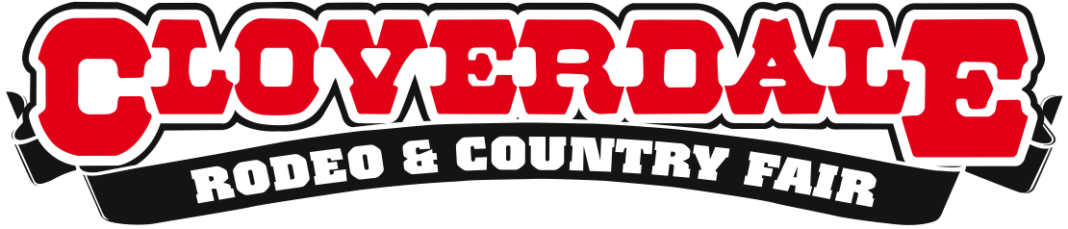

CLOVERDALE RODEO RESULTS: PERFORMANCE XX

Surrey, BC – With one more day to go before the finals on Monday, May 18, the competition began to heat up between the cowboys and the cowgirls here at the 2015 Cloverdale Rodeo. Only one bull rider, Nate Perry from Elk City, OK, managed to stay on the bull for the full eight seconds, earning him a high score of 87 points. Below are the full results of Sunday’s competitions.

Second Performance Results (Pool B) – 2:30pm

Bareback Riding
1. Marvin Alderman, Ibabelle, OK – 87.5 points
1. Mason Clements, Sandy, UT – 87.5 points
3. Jessy Davis, Power, MT – 85 points
4. Taylor Price, Huntsville, TX – 84.5 points
Saddle Bronc Riding
1. Joe Lufkin, Salisow, OK – 88.5 points
2. Bradley Harter, Weatherford, TX – 87.5 points
3. Kyle Thomson, Cowley, AB – 84.5 points
4. Chase Bennett, Santa Quin, UT – 83 points
4. Cody Demoss, Huflen, LO – 83 points
Bull Riding
1. Nate Perry, Elk City, OK – 87 points
Ladies Barrel Racing
1. Kali Parker, Wendell, ID – 15.936 seconds
2. Pamela Capper, Cheny, WA – 16.133 seconds
3. Katie Garthwaite, Merrit, BC – 16.159 seconds
4. Timi Likely, Twin Falls, ID – 16.319 seconds
5. Lindsay Kruse, Greatfalls, MT – 16.368 seconds

The Cloverdale Rodeo concludes tomorrow with finals at 2:30pm. For more information about the Cloverdale Rodeo and Country Fair, visit www.cloverdalerodeo.com.

-30-

Colin Wong  Cloverdale Rodeo and Country Fair  Direct: 604-637-6649  Cell: 604-638-0412  cwong@lbmg.ca | Lesley Chang  Cloverdale Rodeo and Country Fair  Direct: 604-637-6661  Cell: 604-375-1461  lchang@lbmg.ca

