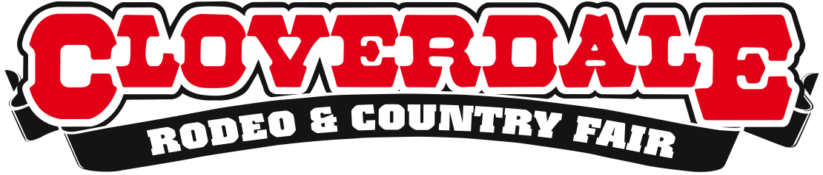

YEEHAW, THE CLOVERDALE RODEO AND COUNTRY FAIR
OPENS TODAY!

For Immediate Release

Surrey, BC – Polish your belt buckle, pull up those cowboy boots and dust off the ol’ cowboy hat because the Cloverdale Rodeo opens today! This classic May long weekend tradition returns to the Cloverdale Fairgrounds with more family-oriented displays, all-new features and specialty performances from two all-new acts, the four-day show is packed full of fun for people of all ages.

The world’s top ranked cowboys and cowgirls are ready to compete for a total of $328,000 in cash prizes in four main events: Saddle Bronc, Bull Riding, Bareback and Ladies Barrel Racing. Cloverdale’s youngest riders will get their chance to shine when Mutton Bustin’ takes centre stage during all five Rodeo performances.
New to this year’s Rodeo are two specialty performers – Vancouver-based BCCMA Female Vocalist of the Year Karen Lee Batten and professional trick rider and liberty horse entertainer, Niki Flundra. Also new to the show is The West Fine Art Show, one of BC’s largest and most prestigious art shows. Between 15 and 20 of the finest artists in Western Canada will be in attendance to discuss and show their work.

After the sun goes down, the adults stay to enjoy live entertainment in the famous Longhorn Saloon, with nightly performances by the Ken McCoy Band, and Ettinger & Big 50. Also catch amazing performances on the Outdoor Stage, where you can swoon to the likes of Appaloosa, Robyn & Ryleigh, Chris Buck, Hey Stewey and more.

Event: 2015 Cloverdale Rodeo and Country Fair
Dates: May 15-18, 2015
Location: Cloverdale Fairgrounds in Surrey, BC
Tickets: Grounds Admission $12
Kids 12 and under FREE (must be accompanied by an adult)
Rodeo Performances $20
Kids 12 and under FREE (must be accompanied by an adult)

For a detailed schedule of event, performances, competitors list, and to purchase tickets, please visit www.CloverdaleRodeo.com.

About the Cloverdale Rodeo and Country Fair:

The Cloverdale Rodeo and Exhibition Association is the non-profit organization that manages the world famous Cloverdale Rodeo and Country Fair, held every year on the May long weekend at the Cloverdale
-more-
Fairgrounds in Surrey, British Columbia. The Association is also responsible for the year-round management
of the eight facilities on the Cloverdale Fairgrounds that host over 1,000 events annually, including trade shows, concerts, festivals, sporting events, horse and dog shows, swap meets, flea markets, weddings and meetings.

For more information on the Association and the 68th annual Cloverdale Rodeo and the 126th Country Fair, visit www.CloverdaleRodeo.com.

-30-

Media Inquiries:

Colin Wong Lesley Chang
Cloverdale Rodeo and Country Fair Cloverdale Rodeo and Country Fair
Direct: 604-637-6649 Direct: 604-637-6661
Cell: 604-638-0412 Cell: 604-675-1461
cwong@lbmg.ca lchang@lbmg.ca

