CORRECTION: Steve Woolsey was incorrectly named as the 2014 Bull Riding Champion in the press release below. Chris Roundy from Spanish Forks, UT, received this honour in 2014. We have corrected and updated the press release below.

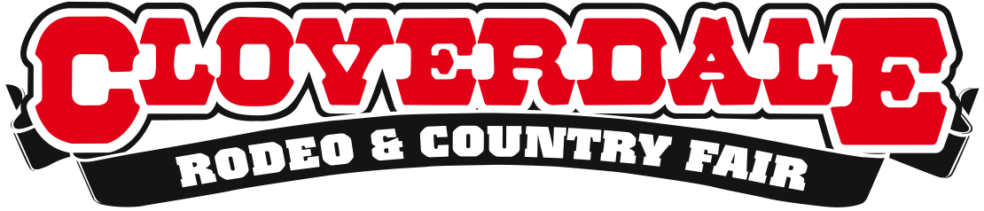

4-Day Rodeo and Country Fair Brings In Big Crowds to One of Western Canada’s Most Popular Family Events
Annual May Long Weekend event celebrates a fantastic year with Cowboys, Skateboarding, Sun and Family Fun!

For Immediate Release
May 18, 2015
Surrey, B.C. – It was an exciting May Long Weekend as the Cloverdale Rodeo and Country Fair celebrated its 69th year of world-class Rodeo action and 127th year of family fun entertainment at the Country Fair. Over 85,000 fairgoers attended the Country Fair, and over 23,000 rodeo fans attended the five Rodeo performances.
With some of the best weather B.C. has seen all year and an enthusiastic rodeo crowd, the Rodeo performances saw some of the strongest crowds in decades. Even with the added seating, the Rodeo saw two back-to-back sell-outs for Saturday and Sunday afternoon performances, and a near sold-out stadium on Monday as well.
The Country Fair showcased the world’s top skateboarders for the 4th annual World Freestyle Round-Up skateboarding competition, where riders representing ten nations competed. Other attractions included the inaugural West Fine Art Show, Richards Racers Pig Racing, West Coast Lumberjack Show, the Cone Zone, and a new BC Country Music Association outdoor music pavilion.

Highlights from this weekend:
World's Top Cowboys and Cowgirls Compete
The 69th annual Cloverdale Rodeo showcased the world’s top cowboys and cowgirls at one of the world’s top ten rodeo events. This year, the winners split over $325,000 in prize money.
Jessy Davis walked away with the $20,000 First Place prize, dominating Bareback Riding all weekend and finishing off strong with a score of 89 on Monday.
Tyrell Larsen dominated the Saddle Bronc competition from start to finish at this year’s Cloverdale Rodeo, winning $20,000 in the final.

Kamloops native Julie Leggett rode to victory in the Ladies Barrel Racing with an impressive time of 16.195 seconds.

The 2008 and 2009 Cloverdale Rodeo Bull Riding champ Steve Woolsey once again takes the grand prize of $44,000 with a score of 86.5. He will be going home with a total of $46,800 for the weekend as well as the title of 2015 Cloverdale Rodeo Bull Riding Champion. He was also the only Bull Rider in the Finals to ride his bull for the full 8 seconds.

Rodeo Finals
Bareback Riding
1) Jessy Davis, Power, MT – 89 points ($20,000 Finals, $23,900 Total)
2) Caleb Bennett, Tremonton, UT- 88.5 points ($10,000 Finals, $11,800 Total)
3) Matt Lait, Cayley, AB- 86.5 points ($5,000 Finals, $6,900 Total)
4) J.R. Vezain, Cowley, WY- 85.5 points ($4,000 Finals, $8,500 Total)
Saddle Bronc Riding
1) Tyrell Larsen, Inglis, MB – 90.5 points ($20,000 Finals, $22,200 Total)
2) Cort Sheer, Eslmere, NE – 89 points ( $11,250 Finals, $14,000 Total)
3) Cody Demoss, Heflin, LA – 84.5 points ($6,250 Finals, $9,700 Total)
4) Bradley Harter, Loranger, LA – 83 points ($5,250 Finals, $7,850 Total)
Ladies Barrel Riding
1) Julie Leggett, Kamloops, BC – 16.195 seconds ($20,000 Finals, $22,400 Total)
2) Timi Likely, Twin Falls, ID – 16.292 seconds ($10,000 Finals, $12,200 Total)
3) Sydni Daines, Red Deer Country, AB – 16.320 seconds ($5,000 Finals, $7,700 Total)
4) Lyndsey Kruse, Great Falls, MT – 16.481 seconds ($4,000 Finals, $5,900 Total)
Bull Riding
1) Steve Woolsey, Payson, UT – 86.5 points ($44,000 Finals, $46,800 Total)
Rounding-Up the World’s Top Skateboarders
Gathering top Pro and Amateur freestyle skateboarders from around the world, the World Freestyle Round-Up took place inside the Cloverdale Curling Rink located on the Cloverdale Fair Grounds, featuring a flawless concrete floor that is ideal for flatland freestyle skateboarding.

The final day of the World Freestyle Round-Up contest saw every competitor stepping up their game big time with White Rock native Andy Anderson taking first place in the Amateur Division, and Surrey locals Dillanger Kane and Chadd Sinclair rounding out Fifth and Tenth Place respectively.
Last year’s First Place Amateur winner, 12-year-old Isamu Yamamoto from Japan, took Fourth Place this year in the World Roundup competing for his first time in the Pro Division. Ultimately, it was Guenter Mokulys from Berlin who cleaned up the competition taking home the Pro division First Place win.
Amateur Division:
- Andy Anderson, White Rock, BC – 263 points
- Kaeu Araujo, São Paulo, Brazil - 262 points
- Diego Pires Afonso, São Paulo, Brazil - 251 points
Pro Division:
- Guenter Mokulys, Berlin, Germany - 265 points
- Mike Osterman, Yorkville, Illinois, USA – 260 points
- Rene Shigueto, São Paulo, Brazil – 259
About the Cloverdale Rodeo and Country Fair:
The Cloverdale Rodeo and Exhibition Association is the non-profit organization that manages the world famous Cloverdale Rodeo and Country Fair, held every year on the May long weekend at the Cloverdale Fairgrounds in Surrey, British Columbia.
The Association is also responsible for the year-round management of the eight facilities on the Cloverdale Fairgrounds that host over 1,000 events annually, including trade shows, concerts, festivals, sporting events, horse and dog shows, swap meets, flea markets, weddings and meetings.
For more information on the Association and the 69th annual Cloverdale Rodeo and the 127th Country Fair, visit www.CloverdaleRodeo.com.

-30-
Media Contacts
Colin Wong  Cloverdale Rodeo and Country Fair  Direct: 604-637-6649  Cell: 604-638-0412  cwong@lbmg.ca | Lesley Chang  Cloverdale Rodeo and Country Fair  Direct: 604-637-6661  Cell: 604-675-1461  lchang@lbmg.ca

