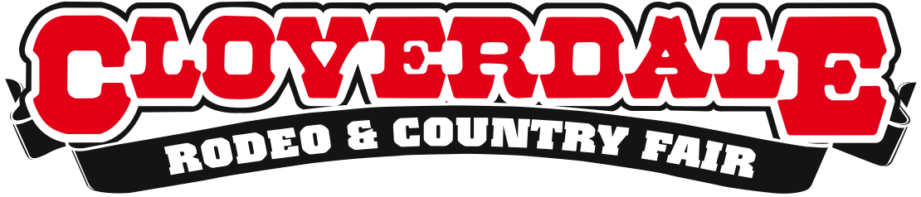
FIRE UP THE GRILL: CLOVERDALE COWBOY COOK-OFF
BBQ COMPETITION IS BACK

Cloverdale, BC – This May long weekend, May 17-20, the Cloverdale Rodeo and Country Fair is where you’ll find the most delicious, aromatic, mouth-watering food served on a paper plate. The Cloverdale Cowboy Cook-Off BBQ Competition and Rib Fest is back and better than ever, where the best BBQ masters from north to south will convene to prove their grill skills and compete for titles and cash.
Presented by Well Seasoned and the Super Save Group, the BBQ Competition will see more than 25 different teams compete for $10,000 in cash prizes and some of the most impressive trophies around. The competition begins Saturday afternoon with a pie bake-off and an Iron Chef style contest, BATTLE BACON, where each team can make anything they want using the supplied protein as the feature ingredient.
After Battle Bacon, teams will start to cook their meat in preparation for the main BBQ competition on Sunday. Competition officially starts Sunday at 11am, and every hour on the hour teams will turn in different meat entries to the judges. Categories include Pork Shoulder, Brisket, Chicken and Ribs. Awards will take place at 5:00pm on Sunday.
Each judge has been trained and certified by the Pacific Northwest BBQ Association. Judges will be evaluating the food based on appearance, texture, taste and flavour. The food is rated on a scale of 1-10 by six different judges. After the teams have submitted their food to the judges, they will pass out samples to the public.
On Monday, three local teams – and some of the best BBQ-ers in the business – will be judged on their finest racks for the Cloverdale Rodeo’s first Canadian Competitors Only Rib Fest. This is the first-ever Rib Fest to be held in the Fraser Valley, and only the 3rd in BC, so Rodeo-goers are in for a real treat! Rib Fest competitors will be serving up their mouth-watering creations all weekend long.
Times:
Everyday
Rib Fest
Saturday May 18th
2:00 pm – Pie Bake Off
4:00 pm – Battle Bacon
Sunday May 19th
11:00 am – Pork Shoulder
12:00 pm – Beef Brisket
1:00 pm – Chicken
2:00 pm – Ribs
5:00 pm – Awards

Monday May 20th
2:00 pm – Rib Fest Judging

For a detailed schedule of events, performances, and to purchase tickets visit www.CloverdaleRodeo.com.
About:

The Cloverdale Rodeo and Exhibition Association is the non-profit organization that manages the world famous Cloverdale Rodeo & Country Fair held every year on the May long weekend at the Cloverdale Fairgrounds in Surrey, British Columbia.

The Association is also responsible for the year-round management of the eight facilities on the Cloverdale Fairgrounds that host over 1,000 events annually, including trade shows, concerts, festivals, sporting events, horse and dog shows, swap meets, flea markets, weddings and meetings.

For more information on the Association and the 67th annual Cloverdale Rodeo and the 125th Country Fair visit: www.cloverdalerodeo.com.

-30-
Media Inquiries
Laura Ballance Carmen Bennett
Cloverdale Rodeo and Country Fair Cloverdale Rodeo and Country Fair
604-637-6646 (direct) 604-637-6651 (direct)
604-771-5176 (cell) 604-762-2250 (cell)
Laura@LBMG.ca Carmenb@LBMG.ca

