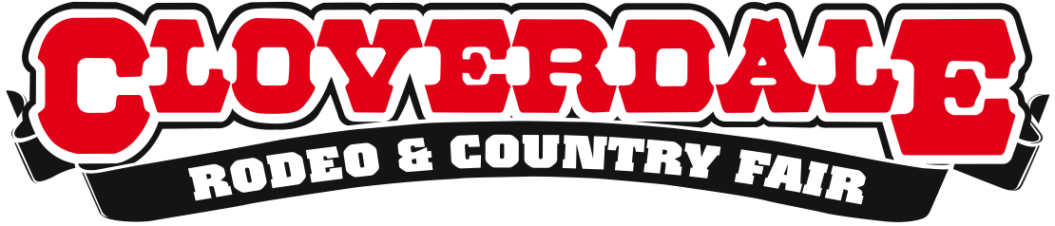
WORLD’S TOP RODEO COMPETITORS SET TO COMPETE IN CLOVERDALE
The Cloverdale Rodeo and Country Fair is Back May 15-18 2015
For Immediate Release
May 6, 2015

Surrey, BC – The most fiercely talented professional cowboys and cowgirls in the world will descend on Cloverdale this month to compete at one of the worlds top rodeo events, the Cloverdale Rodeo and Country Fair.
The 69th annual Cloverdale Rodeo features Bareback, Saddle Bronc, Bull Riding and Ladies Barrel Racing at each of five Rodeo performances. One of the richest rodeos in North America, competitors face off for over $325,000 in prize money.
“This year’s crop of elite veteran competitors along with the next wave of young athletes will deliver an amazing exhibition of athleticism and an unparalleled rodeo experience,” says Cloverdale Rodeo Chair Penny Smythe. “We are excited to welcome the best of the best in the sport of rodeo.”

Competitors to watch for at the 2015 Cloverdale Rodeo include: Caleb Bennett, the 2014 Cloverdale Rodeo Bareback champion, and currently ranked seventh in the world in the 2015 standings; Wade Sundell, third in the World 2014 Final Standings, currently sitting in seventh place in the World Standings; Dustin Flundra, three time Canadian Saddle Bronc Champion, and fourth in the 2014 Canadian Final Standings; Dakota Buttar, 2014 Canadian Bull Riding Champion; Steve Woolsey, a finalist on the third season of reality TV show “Toughest Cowboy,” and the 2008/2009 Cloverdale Rodeo Champion; Steffanie Mather, new to the circuit, and the 2014 Canadian ladies barrel racing champion. For more information about the Cloverdale Rodeo and Country Fair please visit http://www.cloverdalerodeo.com.
About the Cloverdale Rodeo and Country Fair:
The Cloverdale Rodeo and Exhibition Association is the non-profit organization that manages the world famous Cloverdale Rodeo and Country Fair, held every year on the May long weekend at the Cloverdale Fairgrounds in Surrey, British Columbia.
The Association is also responsible for the year-round management of the eight facilities on the Cloverdale Fairgrounds that host over 1,000 events annually, including trade shows, concerts, festivals, sporting events, horse and dog shows, swap meets, flea markets, weddings and meetings.
For more information on the Association and the 69th annual Cloverdale Rodeo and the 127th Country Fair, visit www.CloverdaleRodeo.com.
-30-
Media Inquiries:

Colin Wong Lesley Chang
Cloverdale Rodeo and Country Fair Cloverdale Rodeo and Country Fair
Direct: 604-637-6649 Direct: 604-637-6661
Cell: 604-638-0412 Cell: 604-675-1461
cwong@lbmg.ca lchang@lbmg.ca

