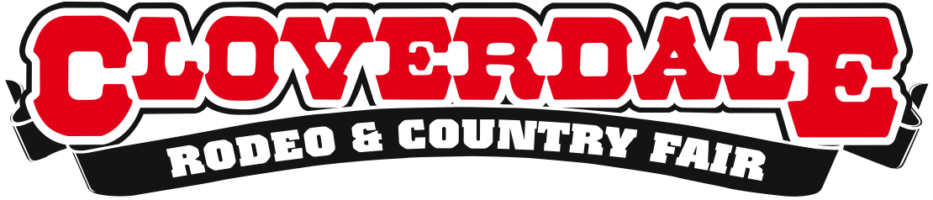

Cloverdale Rodeo & Country Fair Launches Scholarship Program

For Immediate Release
Surrey, BC – The Cloverdale Rodeo & Exhibition is thrilled to present its first annual Scholarship Program, open to past and present Cloverdale Rodeo & Exhibition volunteers who are currently in their final year of high school. Applicants vying for one of two $500 scholarships will be chosen based on their volunteer participation, community involvement, academic performance and demonstration of leadership.
The scholarship is as an initiative to recognize and award student efforts and foster youth participation and engagement in the activities of the Cloverdale Rodeo & Exhibition Association. The Scholarship Committee hopes to make a larger impact with its volunteer program by providing financial assistance as students navigate their lives through their final year in high school and transition to post-secondary education.
“The desire to recognize the unparalleled efforts of student volunteers has been at the forefront of our discussion,” says Cloverdale Rodeo President Shannon Claypool. “Each year the Rodeo relies on hundreds of volunteers to help make the event a huge success, and the team of amazing students is a large and integral part of the organization and operation.”
In addition to the Scholarship Program, the Association is working to expand the roles youth volunteers play within the organization by creating an enhanced and more valuable experience and partnering enthusiastic and motivated students with inspiring mentors.
Applicants will be asked to fill out a form outlining their education, extracurricular and volunteer activities, career plans and other relevant information. Students will also enclose a 300-500 word essay describing the role agriculture plays in society today. The application deadline is Tuesday, May 20th, 2014 and scholarships will be awarded no later than Friday, May 30th, 2014.
The 2014 Cloverdale Rodeo and Country Fair will be held from May 16-19, 2014 at the Cloverdale Fairgrounds in Surrey, BC. For a detailed schedule of event, performances, competitors list, and to purchase tickets, please visit www.CloverdaleRodeo.com.

About the Cloverdale Rodeo and Country Fair:
The Cloverdale Rodeo and Exhibition Association is the non-profit organization that manages the world famous Cloverdale Rodeo and Country Fair, held every year on the May long weekend at the Cloverdale Fairgrounds in Surrey, British Columbia.
The Association is also responsible for the year-round management of the eight facilities on the Cloverdale Fairgrounds that host over 1,000 events annually, including trade shows, concerts, festivals, sporting events, horse and dog shows, swap meets, flea markets, weddings and meetings.
-more-
For more information on the Association and volunteer opportunities at the 68th annual Cloverdale Rodeo and the 126th Country Fair, visit www.CloverdaleRodeo.com.
-30-
Media Inquiries:
Amanda Ribeiro
Cloverdale Rodeo and Country Fair
604-637-6655 (direct)
604-375-1461 (cell)
Amanda@LBMG.ca

