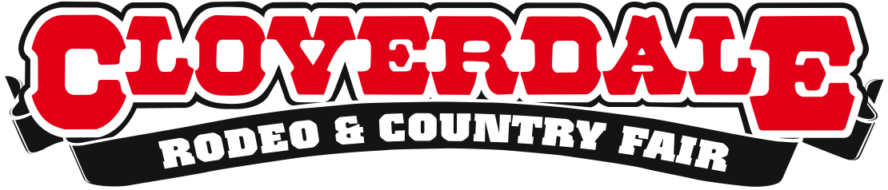
GET YOUR APPETITES READY FOR THE LONG WEEKEND!
RIB FEST IS BACK MAY 15-18 2015
For Immediate Release
May 11, 2015
Surrey, BC – Bring your ten-gallon appetite to the 2015 Cloverdale Rodeo and Country Fair as top barbecue chefs from across Canada are back to serve their authentic, finger licking good Southern style barbecue at this year’s Cloverdale Rodeo and Country Fair.
North Vancouver’s own Smoke and Bones, 2012 Canadian National BBQ Champions, will be serving up their award winning slow cooked ribs, pulled pork, chicken, beef brisket and famous sides.
Ontario favourite Boss Hoggs BBQ will be living up to their motto: ‘Taste the Smokin’ Difference.’ Their celebrated chicken and ribs all weekend will wow even the most seasoned barbecue enthusiasts.
Prairie Smoke & Spice pride themselves on being the home of genuine pit-smoked barbecue catering in southern Saskatchewan. One taste of their award winning succulent and juicy barbecue will have fair goers coming back for seconds.
For a detailed schedule of events, performances, and to purchase tickets visit www.CloverdaleRodeo.com.
About the Cloverdale Rodeo and Country Fair:
The Cloverdale Rodeo and Exhibition Association is the non-profit organization that manages the world famous Cloverdale Rodeo and Country Fair, held every year on the May long weekend at the Cloverdale Fairgrounds in Surrey, British Columbia.
The Association is also responsible for the year-round management of the eight facilities on the Cloverdale Fairgrounds that host over 1,000 events annually, including trade shows, concerts, festivals, sporting events, horse and dog shows, swap meets, flea markets, weddings and meetings.
For more information on the Association and the 69th annual Cloverdale Rodeo and the 127th Country Fair, visit www.CloverdaleRodeo.com
-30-

Media Inquiries:

Colin Wong Lesley Chang
Cloverdale Rodeo and Country Fair Cloverdale Rodeo and Country Fair
Direct: 604-637-6649 Direct: 604-637-6661
Cell: 604-638-0412 Cell: 604-675-1461
cwong@lbmg.ca lchang@lbmg.ca

