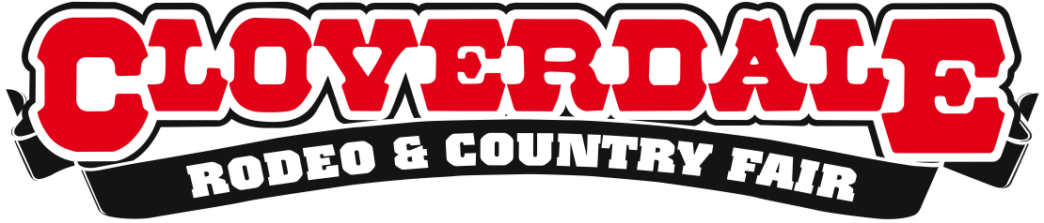

The West Fine Art Show to open at the 69th Annual Cloverdale Rodeo
20 Western Canadian artists connect people, art and charitable
purpose in sixth annual West Fine Art Show
For Immediate Release
May 7, 2015

Surrey, BC – The Cloverdale Rodeo and Country Fair is proud to host some of the finest artists in Western Canada at The West Fine Art Show happening at the 69th annual Cloverdale Rodeo and 127th annual Country Fair. This special exhibition is free with admission to the popular annual event, May 15 to 18 at the Cloverdale Fairgrounds.
Event curator Murray Phillips, himself a seasoned artist from Langley, founded the event to fulfill his vision of bringing together a group of exceptionally talented western Canadian artists in a single show 2009. The resulting West Fine Art Show has been a tradition in the region for enthusiasts of art that celebrates the western lifestyle.
“The West Fine Art Show was always a dream of mine,” says Phillips. “We’re featuring 20 artists at the Cloverdale Rodeo and Country Fair and fairgoers can connect with the artists and their beautiful pieces of art. I want to invite everyone to join us for this show and support two worthy local charitable foundations.”
Hosted by the Cloverdale Rodeo, Phillips has further partnered with Vancouver’s C.H.I.L.D. Foundation, a foundation dedicated to finding a cure for children stricken with Crohn’s Disease, Ulcerative Colitis and liver disorders. He has also partnered with The Cloverdale Rodeo Youth Initiative Foundation, which provides scholarships to past and present student volunteers at the Cloverdale Rodeo and Exhibition Association. A portion of all art sales will be donated to these two worthy causes.
The artists featured in the West Fine Art Show include highly acclaimed Langley artist Brian Croft, whose intricate work emanates from the beautiful locales surrounding Vancouver. He has been painting the history of BC for almost 20 years and has created over 380 works of art. Another artist to watch for is Gaye Adams, whose oil paintings are created en plein air and draw the viewer in with her expert use of colour and light.
For more information about the Cloverdale Rodeo and Country Fair visit: www.cloverdalerodeo.com.
For more information about the West Fine Art Show, and for a full list of feature artists who will be at the Cloverdale Rodeo and Country Fair visit www.westart.ca

About the Cloverdale Rodeo and Country Fair:
The Cloverdale Rodeo and Exhibition Association is the non-profit organization that manages the world famous Cloverdale Rodeo and Country Fair, held every year on the May long weekend at the Cloverdale Fairgrounds in Surrey, British Columbia.
The Association is also responsible for the year-round management of the eight facilities on the Cloverdale Fairgrounds that host over 1,000 events annually, including trade shows, concerts, festivals, sporting events, horse and dog shows, swap meets, flea markets, weddings and meetings.
For more information on the Association and the 69th annual Cloverdale Rodeo and the 127th Country Fair, visit www.CloverdaleRodeo.com.
-30-
Media contacts
Colin Wong  Cloverdale Rodeo and Country Fair  Direct: 604-637-6649  Cell: 604-638-0412  cwong@lbmg.ca | Lesley Chang  Cloverdale Rodeo and Country Fair  Direct: 604-637-6661  Cell: 604-675-1461  lchang@lbmg.ca

